
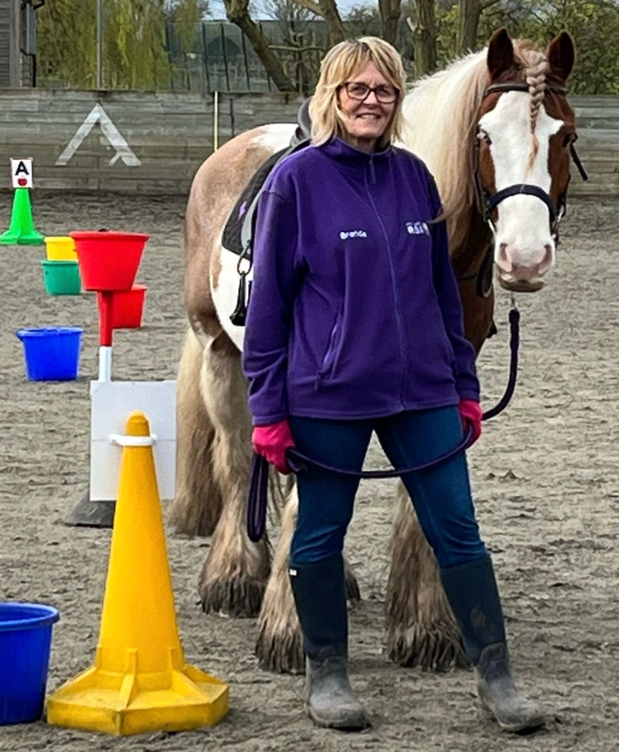
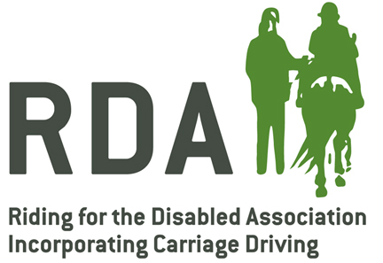
Volunteers Wanted

STEVENAGE RDA
Charity No: 1074422

We meet at
Model Farm, Hanscombe End Road, Shillington SG5 3NA

Monday
09:15 to 12:00
Thursday
09:15 to 12:00

Contact us to find out more


stevenagerdainfo@gmail.com


01462 436625


www.stevenagerda.org
Join us and make a difference!
Our volunteers help children and adults with physical and/or learning disabilities to ride and interact with ponies for therapy, achievement and fun.
Please contact us to find out more. No knowledge of horses is necessary.

