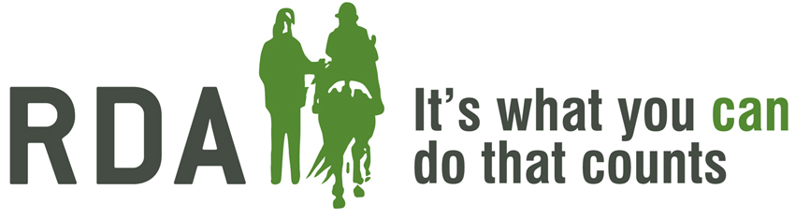
GIFT AID DECLARATION

STEVENAGE GROUP RDA
Charity No. 1074422

Please treat the enclosed gift of £______ as a Gift Aid Donation.
I confirm I have paid or will pay an amount of Income Tax and/or Capital Gains Tax for the
current tax year (6 April to 5 April) that is at least equal to the amount of tax that all the
charities that I donate to will reclaim on my gifts for the current tax year. I understand the
charity will reclaim 25p of tax on every £1 that I have given.
Donor Details
Title ________ First Name(s) ___________________________________________
Surname ________________________________________

Home Address __________________________________________________________

___________________________________________ Postcode __________________
Donor Signature _____________________________ Date ______________________

Please notify RDA if you:
- Want to cancel this declaration
- Change your name or home address
- No longer pay sufficient tax on your income and/or capital gains
If you pay Income Tax at the higher or additional rate and want to receive the additional tax
relief due to you, you must include all your Gift Aid donations on your Self Assessment tax
return or ask HM Revenue and Customs to adjust your tax code.

Contact:
Sue Tarbox (Treasurer)
30 Vicarage Road
Silsoe
MK45 4EF

